Experiment:5 implement the Vacuum Cleaner Problem using Python
Aim
o implement the Vacuum Cleaner Problem using Python.
Algorithm
- Assume two rooms: A and B.
- Check the current location of the vacuum cleaner.
- If the room is dirty, clean it.
- Move to the next room.
- Repeat until all rooms are clean.
- Display the final state of the rooms.
Program
# Vacuum Cleaner Problem
rooms = {'A': 'Dirty', 'B': 'Dirty'}
location = 'A'
while True:
print("Vacuum is in Room", location)
if rooms[location] == 'Dirty':
print("Cleaning Room", location)
rooms[location] = 'Clean'
if location == 'A':
location = 'B'
else:
break
print("\nFinal State:")
for room in rooms:
print(room, ":", rooms[room])

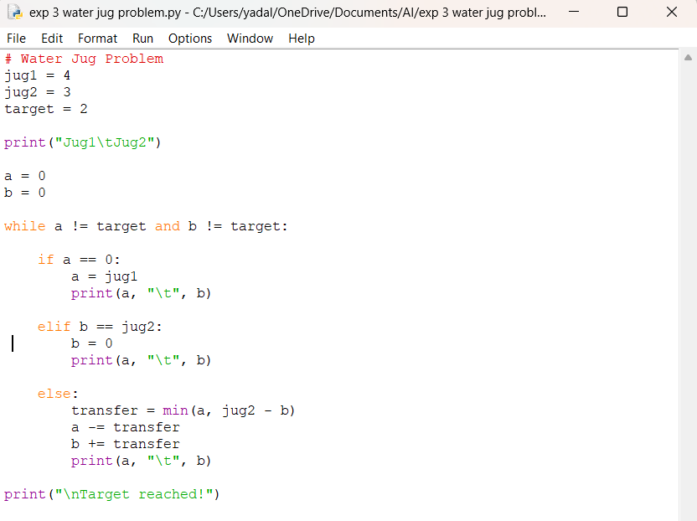
Sample Output
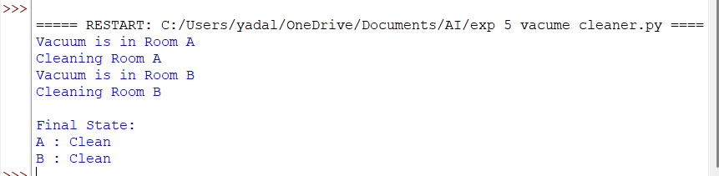 Result
The Vacuum Cleaner Problem was successfully implemented in Python. The vacuum cleaner cleaned all dirty rooms and reached the goal state where both rooms were clean.

